**Kocaeli University Electronics and Telecommunication Engineering**

**Digital Communications Laboratory**

**Experiment 6:BPSKModulation and Demodulation – Simulink Lab Report**

In phase shift keying (PSK), the phase of a carrier is changed according to the modulating waveform which is a digital signal. In Binary Phase Shift Keying (BPSK), the transmitted signal is a sinusoid of fixed amplitude. It has one fixed phase when the data is at one level and when the data is at the other level, the phase is different by 180 degrees. A BPSK signal can be defined as

$s_{BPSK}(t)=A Cos\left(2πf_{c}t+\left\{\begin{matrix}0 if m\left(t\right)=1 \\ π if m\left(t\right)=0\end{matrix}\right.\right)$,where m(t) is the binary information.

In the lab experiment, Bernoulli Binary generator block generates 0 and 1 bits with equal probability. Unipolar to Bipolar converter is employed. *M* should be 2 in this block. Thus, the output of the adder module becomes a polar signal (+/-1). Then, the polar signal is multiplied by a carrier signal whose frequency is $f_{c}$ and BPSK modulated signal is obtained.

At the receiver part, the signal is multiplied with the carrier that is same carrier signal at the transmitter part. This demodulation is called Coherent Demodulation. Construct the below block diagram for baseband BPSK Modulation & Demodulation.

**Figure 1** Baseband BPSK Modulator and Demodulator Block Diagram

**Required Blocks**

1. Bernoulli Binary Generator
2. Sine Wave for carrier signal
3. Gain
4. Sum
5. Multiplier
6. Analog filter
7. Inequality
8. Scope
9. Error Rate Calculation
10. Display

**Table 1.** Parameters for Carrier Sine Wave

|  |  |
| --- | --- |
| Amplitude | 1 |
| Frequency | 2*pi*1000 |
| Phase | pi/2 |
| Sample Time | 1e-5 |

**Table 2.** Parameters for Analog Filter Block

|  |  |
| --- | --- |
| Design method | Butterworth |
| Filter type | Low pass |
| Filter order | 8 |
| Passband edge frequency | 2*pi*100 |

**Figure 2** Source property

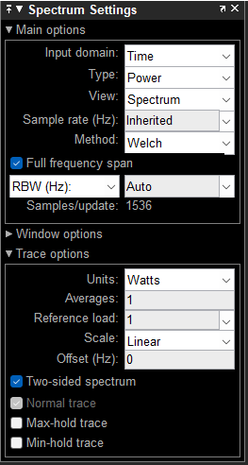

**Figure 3** Spectrum Settings

**Figure 4** Error Rate Calculation Config

1. Set the carrier frequency as $f_{c}=1000$ Hz. Run the code for 0.08 seconds. After obtaining BPSK signal, take a screenshot of the scope result of the message signal and explain what you see.

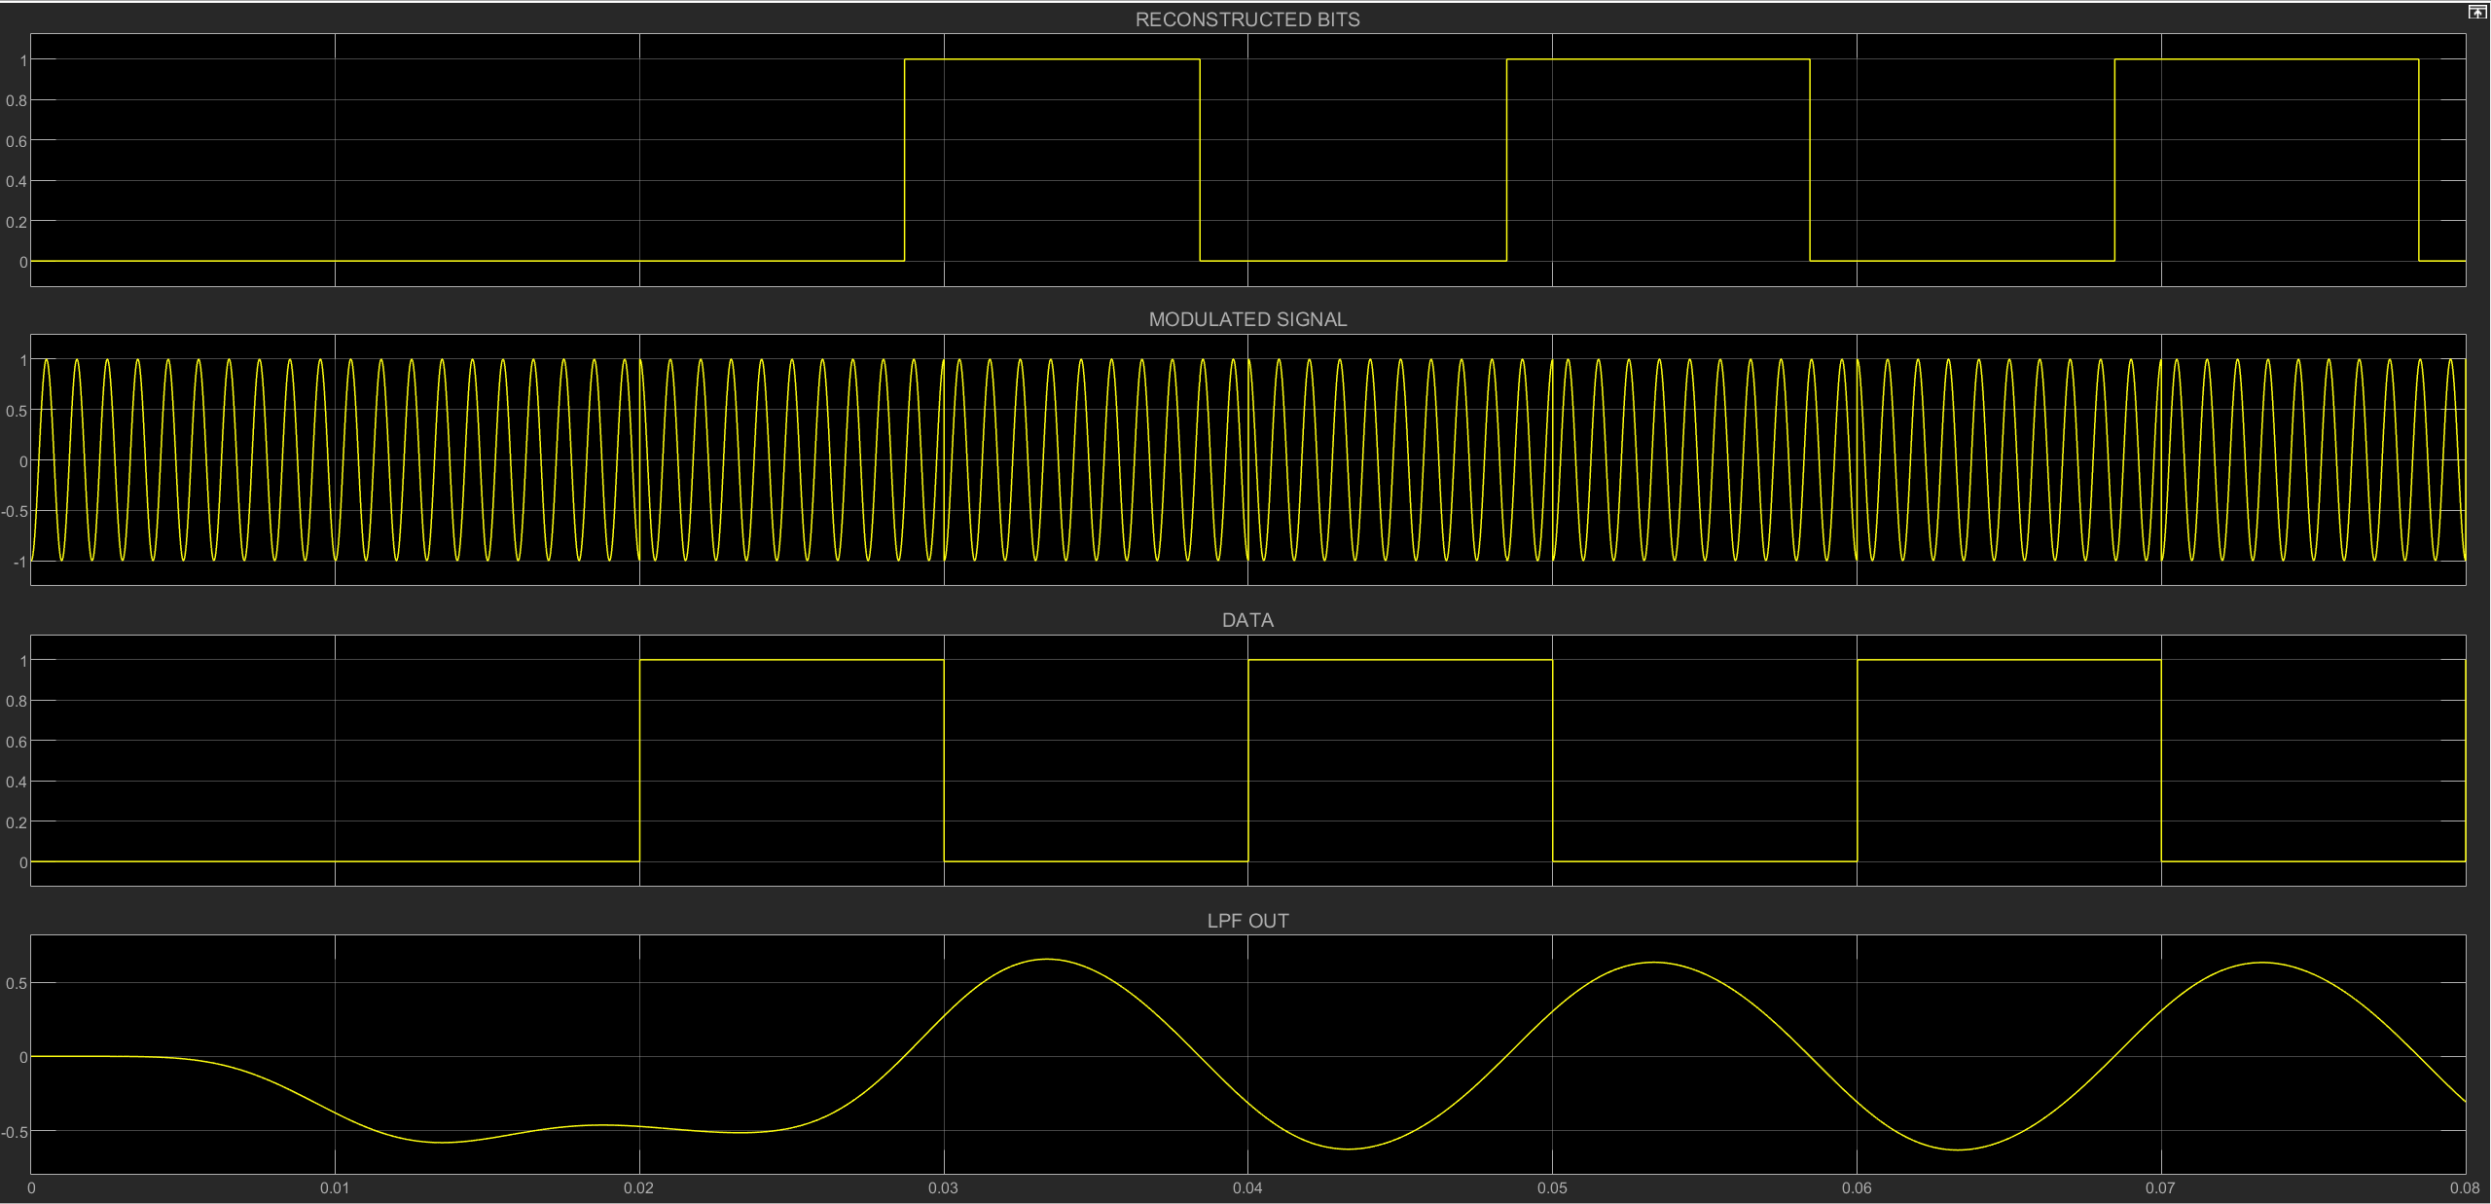

1. What is the bandwidth of the BPSK modulated signal according to first zero-crossing? Observe it using spectrum analyzer. Hint: Set the simulation stop time as 5 Sec, sample time of the zero-order holder as-1. Use the spectrum settings illustrated in Figure 3.

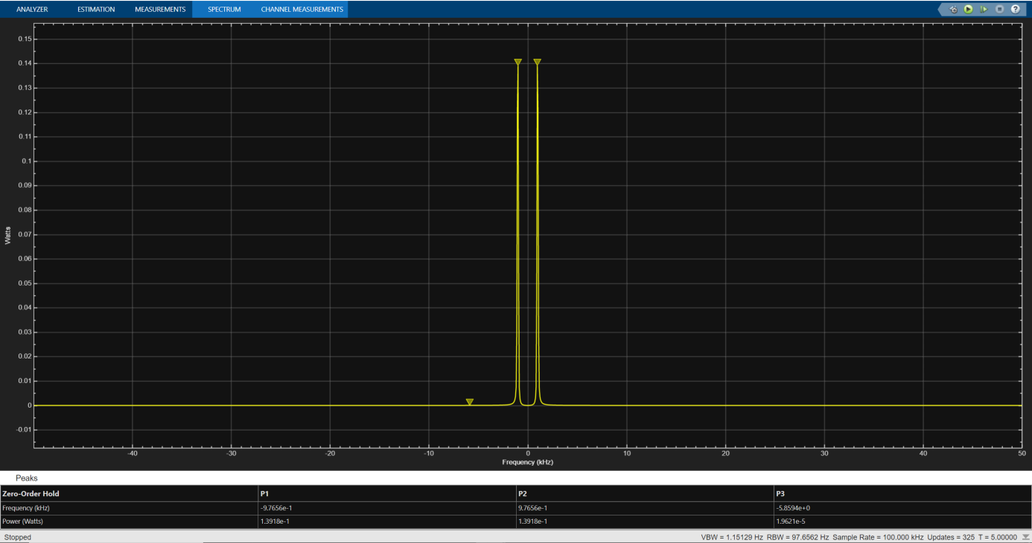

1. In Figure 1, the same local oscillator is used at the transmitter and the receiver. To investigate the phase effect, set the value of the constant block in Figure 5 equal to 0.25e-3 and 0.5e-3. Observe the LPF outputs and add their screenshots to your report. Observe BER values and fill them in the table below, explain the reason for errors (Simulation Stop time must be 5 Sec).

**Figure 5** Generating phase shift

|  |  |  |
| --- | --- | --- |
| **Time Delay** | **BER Value** | **Explain** |
| 0.25e-3 | 0.002 |  |
| 0.5e-3 | 1 |  |

*Karar eşiği arttığı için, Qfonk içi azalır; hata olasılığı Pb artar.*

1. Set the value of the constant block in Figure 5 equal to 0. Change Sample time of Bernoulli Binary Generator block**(source)** as (1/200). Observe its effect on scope and spectrum analyzer. Does the bandwidth of the modulated signal change? Explain why.

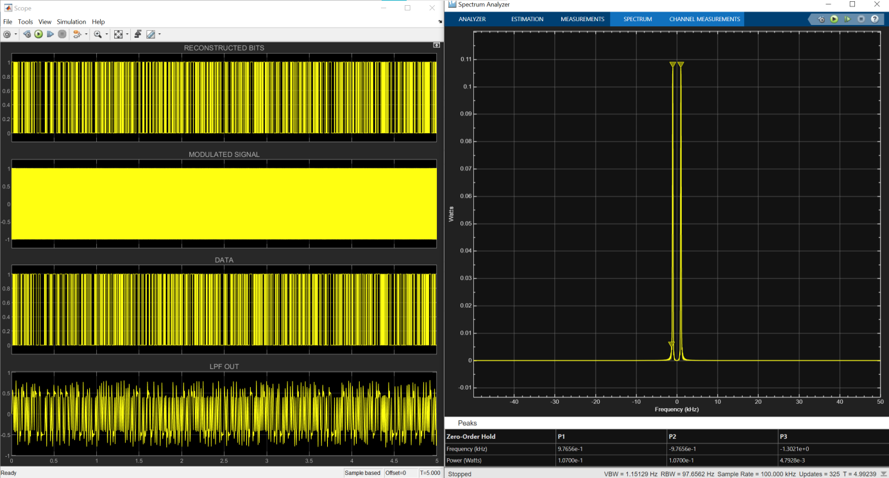

1. At the receiver low pass filter (LPF) is used for coherent demodulation. When sample time of **source** changes, should we change the cut-off frequency of LPF? Is there any relation between them?

*In coherent demodulation of BPSK (Binary Phase Shift Keying), a low-pass filter (LPF) is typically used to recover the original baseband signal from the received modulated signal. The cutoff frequency of the LPF determines the bandwidth of the filtered signal and affects the demodulation process.*

*When the sample time of the source changes, it can indeed affect the demodulation process, particularly if the change in the sample time leads to a significant change in the signal bandwidth. If the sample time decreases, meaning more samples are taken per unit time, the effective bandwidth of the signal may increase. Conversely, if the sample time increases, the effective bandwidth may decrease.*

*In order to maintain optimal demodulation performance, it's generally advisable to adjust the cutoff frequency of the LPF accordingly when there is a change in the sample time. The relationship between the sample time and the cutoff frequency can be approximated based on the Nyquist-Shannon sampling theorem, which states that the sample rate should be at least twice the maximum frequency component of the signal being sampled to accurately reconstruct the original signal.*

*Therefore, if the sample time decreases (more samples per unit time), the cutoff frequency of the LPF may need to be increased to accommodate the higher frequency content in the signal. Conversely, if the sample time increases (fewer samples per unit time), the cutoff frequency of the LPF may need to be decreased to avoid aliasing and to filter out the appropriate frequency components.*

*In summary, there is indeed a relationship between the sample time and the cutoff frequency of the LPF in coherent demodulation of BPSK, and adjusting the cutoff frequency appropriately based on changes in the sample time can help maintain optimal demodulation performance.*